Ejercicio 1
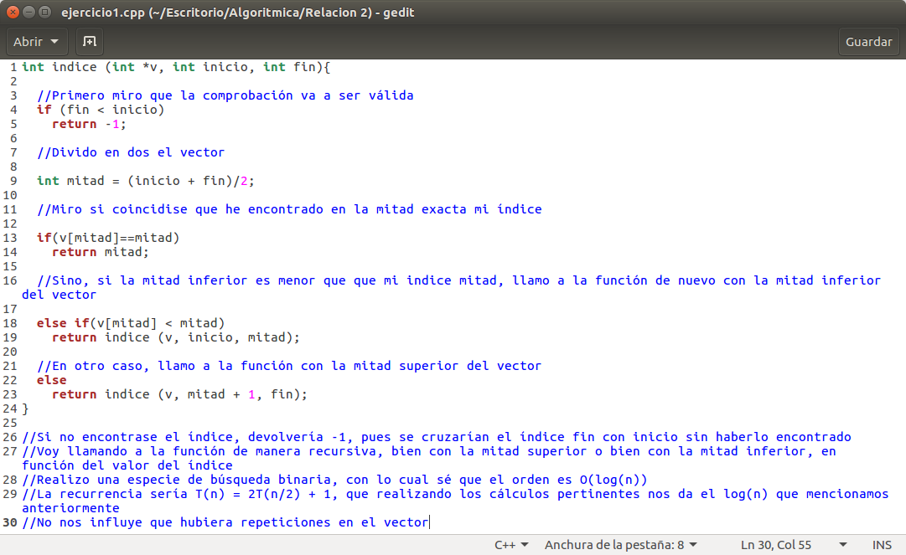
T(n) = T (n/2) + 1
n = 2^m
T(2^m) − T(2^(m−1)) = 1
x = T(2^m)
1 = b^m ∗ p(m)
b = 1
p(m) = 1
d = 0
(x − 1)(x − 1) = 0
T(2^m) = c1 ∗ 1^m + c2 ∗ m ∗ ^m
T(n) = c1 ∗ 1^(log2(n)) + c2 ∗ log2 (n) ∗ 1^(log2 (n))
T(n) = c1 + c2 ∗ log2 (n)

Ejercicio 3
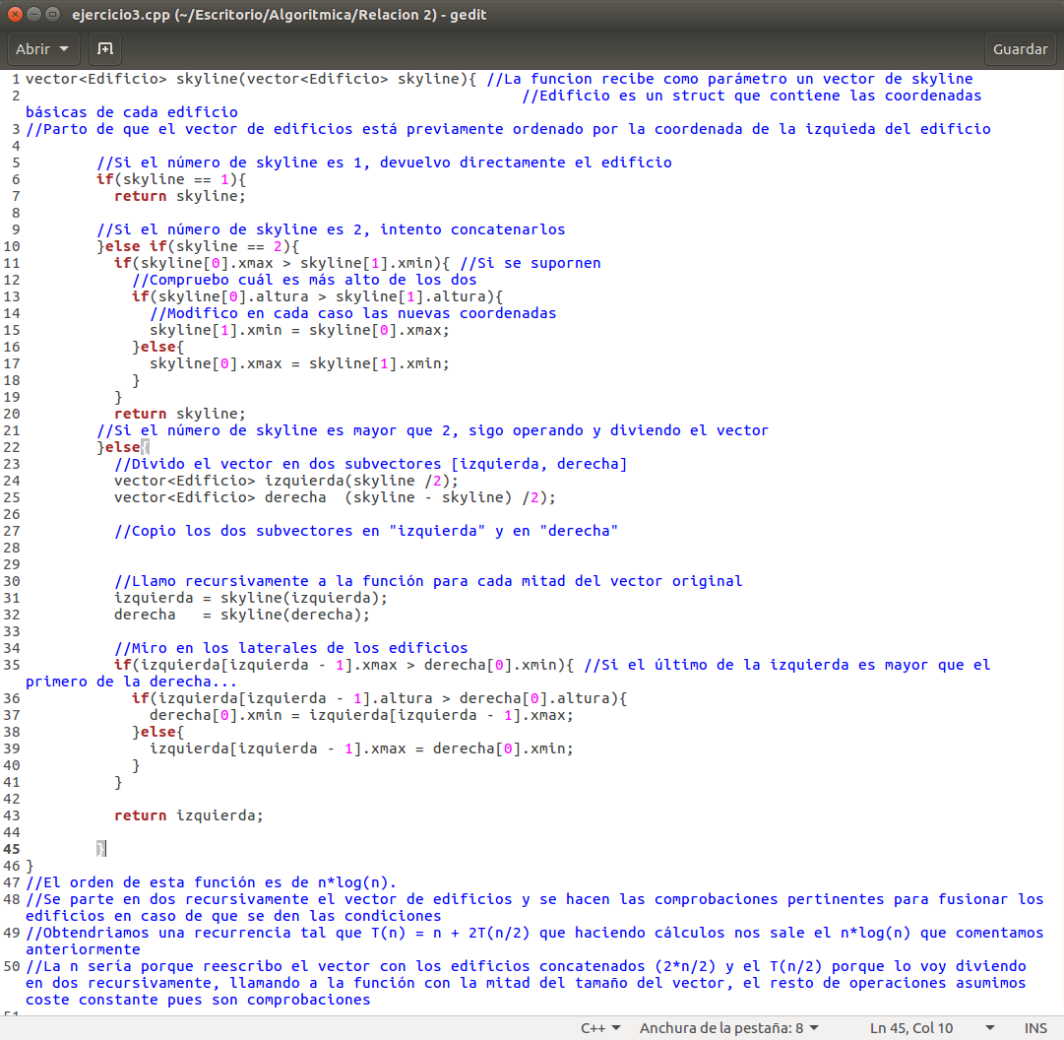
T(n) = n + 2T (n/2)
n = 2^m
T(2^m) − 2T(2^(m−1)) = 2^m
x = T(2^m)
2^m = b^m ∗ p(m)
b = 2
p(m) = 1
d = 0
(x − 2)^2 = 0
T(2^m) = c1 ∗ 2^m + c2 ∗ m ∗ 2^m
T(n) = c1 ∗ n + c2 ∗ log2 (n) ∗ n
Ejercicio 4
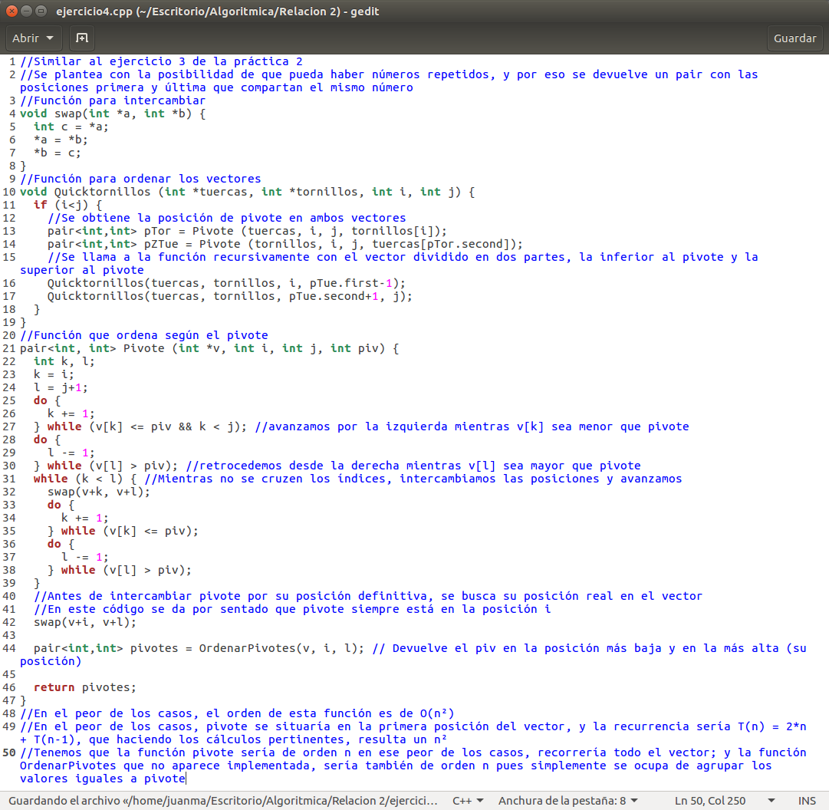
T(n) = 2 ∗ n + T(n − 1)
T(n) − T(n − 1) = 2 ∗ n
x = T(n)
2 ∗ n = b^n∗ p(n)
b = 1
p(n) = n
d = 1
(x − 1)^3 = 0
T(n) = c1 ∗ 1^n + c2 ∗ n ∗ 1^n + c3 ∗ n^2∗ 1^n

Ejercicio 5
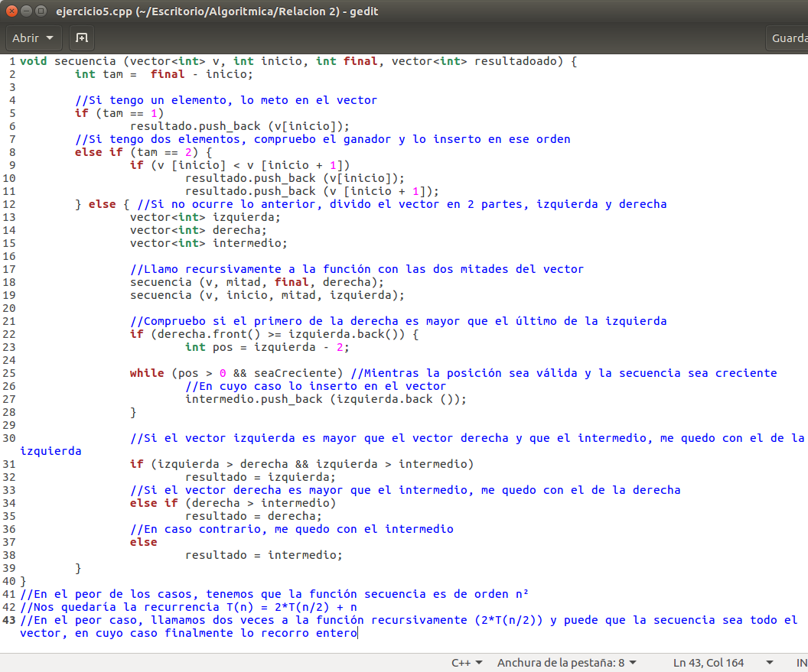
T(n) = n + 2T (n/2)
n = 2^m
T(2^m) − 2T(2^(m−1)) = 2^m
x = T(2^m)
2^m = b^m ∗ p(m)
b = 2
p(m) = 1
d = 0
(x − 2)^2 = 0
T(2^m) = c1 ∗ 2^m + c2 ∗ m ∗ 2^m
T(n) = c1 ∗ n + c2 ∗ log2 (n) ∗ n

